Written by: Ethan Lin, Alia Starman Last Update: 05/06/2026

Mold making

Resin (~20 min active, at least a day until usable)
- Check the resin level to ensure there is enough and clean the resin plate with a scraper
- Put the resin plate into the printer, lock in place, close the lid. Push open the chimney (air outlet) of the resin cartridge in back of printer
- Upload the .stl file of print into PreForm. Ensure that your settings are to the resin type (usually biomed clear) and correct printer (RussetDingo if in McGhee lab). You may have to connect to the USB cable to see RussetDingo.
- Orient part correctly for best outcome for intended use.
  - SLA printers are layer by layer, so if absolutely flat features are desired make sure those are parallel to the base plate.
  - Supports are often used for complex shapes and make it easier to take the print out. However, a chamfer bottom will make this process doable without support.
- Start printing. Once print is uploaded then you can unhook USB from printer
- When print is finished, take out plate and scrape down uncured resin around parts into the printer
- To take out the print, use the scraper to remove parts attached to the mounting plate. Spray with IPA to initially get rid of lumpy material.
  - If you did not use supports, take the scraper and shove it in between the part and the metal plate. With the plate facing downwards, apply torque with the scraper to pull the piece off. This may take several attempts. Use a paper towel to prevent too much of a mess.
- Put parts into the IPA cleaner for 20-30 min.
  - In the McGhee lab you may have to take the round plug adapter from the curing chamber to plug in the cleaner
- Add the parts to the Draft V2 resin bath for 1 hour (do not leave for much longer). Spray with IPA following secondary coating.
- Use the UV curing for 1 hour at 60 C.
  - Again, move the round plug adapter from the IPA bath to the UV curing chamber.
- Put in 80 C oven overnight before pouring first PDMS chip

PDMS aliquots (15-20 min)
- By volume in the McGhee lab to reduce messing up the scale and making a mess. Monomer and crosslinker aliquots are stored in syringes in -20 C. Ask Dr. McGhee if you need more aliquots
  - For the crosslinker, remove the plunger of a 10mL syringe tube. Put a 3D printed cap on, and pour 8-9 mL of cross linker into the syringe. Carefully hold the plunger to the syringe, flip, CAREFULLY eject the excess air until the plunger is properly inserted back into the syringe.
  - For the monomer, open the bucket and fill 25mL syringe tubes. Only dip the protrusion of the tube into the liquid. Make sure to use a paper towel to clean the syringe edges following the fill, and put the 3D printed cap on.
- In a large weight boat, add 10:1 monomer:crosslinker (25 mL monomer → 2.5 mL crosslinker). Add the monomer first and then the crosslinker.
  - When putting the crosslinker in, ensure that you have full control over the syringe, as it can easily spray out when you put too much pressure. You almost want it to just drip out into the weight boat.
- With a wooden stick, mix vigorously for around 3 minutes. You want the mix to turn white due to the air bubbles you are introducing.*
- Once mixed, pour from the top into a new 25mL syringe
  - Pull the syringe plunger out of the body
  - Put the 3D printed cap onto the syringe opening to prevent the PDMS from pouring out.
  - Pour the PDMS through the top of the syringe
  - Put the plunger back in and try to push it until it clicks in. Flip the syringe over waiting for the air bubble to come to the top. Slightly unscrew the cap (careful as the pressure may blow it off) and push the plunger fully in. Screw the cap back in.
- Label the new aliquot 10:1 PDMS with a date and initials. Put it into the -20 C PDMS bucket, cap-side down. After a few hours the air bubbles will have risen to the top and form one large bubble.

*If you need PDMS immediately with no aliquots made
After step 3, put the mixed PDMS into a vacuum. Make sure to lay down paper towels in case it overflows. Turn on the vacuum and all air bubbles will rise to the top. This degased PDMS can be used immediately. Excess can be stored at -20 C.

Chip making

Soft lithography (15 min active, 1 hour wait)
- Push desired amount of 10:1 PDMS into the mold
  - Make sure to not pour over the inlet/outlet holes
- To remove any bubbles that may be introduced, place mold into a plastic tray and into the vacuum chamber. Turn on the vacuum for around 5 minutes.
  - Make sure to not fill the chip fully if using vacuum, as it will bubble over and create mess (plastic tray is there to catch it, but it gets on the outside of the mold)
  - Any additional big bubbles that form can be removed easily by fishing it out with a pipette tip
- Put degassed mold into 80 C oven for at least 1 hour to cure fully

Plasma bonding (20 min active, 1 hour wait)
- Clean off glass coverslip with IPA, lens cleaner cloth, and tape. You may use air if necessary.
- Remove the PDMS out of the mold
  - To remove the PDMS mold, spray IPA on top. Insert the thin, rounded point of the spatula, the mold and the PDMS. You will see an air pocket form where the IPA leaks in and creates separation of the mold and chip. Create a large insertion on a side.
  - Try to remove the mold parallel to the channel direction, and lift slowly. If cured correctly this the PDMS should maintain its shape and flexibly lift off. Note that any small tear turns into a big one easily
  - Clean the PDMS surface with tape and air
- Place glass and PDMS into the plasma chamber. Make sure the channel-side of the PDMS is face up
- Turn on vacuum and air to the plasma chamber (~1 torr, ~10 flowmeter O2, ~1 flowmeter Ar). Refer to the appendix for images of the system with labeled parts.
  - Turn the barometer and plasma chamber on
  - Turn the black knob on the plasma chamber all the way to the right to allow the vacuum through
  - Use the switch to turn the vacuum on (you will hear it start up) and then slightly press the door to the chamber to create a seal (you will hear the vacuum quiet down slightly, and see the barometer pressure go down)
  - Once the vacuum is ~1 torr, turn on the desired gas tanks by twisting their main silver knobs
  - Twist the silver knob near the black plasma chamber knob open. You will see the flowmeter bubbles bob up slightly when flow is on. If not, make sure the air tanks are on.
  - Use flowmeter knobs to get O2 to around 10 and Ar to 1. The pressure will rise again, but wait til it decreases to ~1 torr again.
  - Turn on plasma to high for 1 minute (should see a white haze inside)
- Do the reverse of step 4: turn plasma off, shut sliver knob, turn off gas tanks, shut vacuum off
  - Slowly let out vacuum from the chamber by twisting the black knob
- Take out the PDMS and glass slide slowly without touching the surface facing up, and then put the PDMS channel side onto the glass slide (top side onto top side)
  - You will see the opacity of the two change from cloudy to more clear/darker if plasma bonded
  - Only if absolutely necessary can you use a spatula and press around areas to initial the bonding contact. DO NOT PRESS NEAR CHANNELS AS THIS MAY CLOSE THEM OFF
- Place chip into 80 C oven for at least 30 minutes to finish the bonding
- Add inlet/outlet tubes with PDMS if desired, and let cure for another 1 hour before use.

Appendix
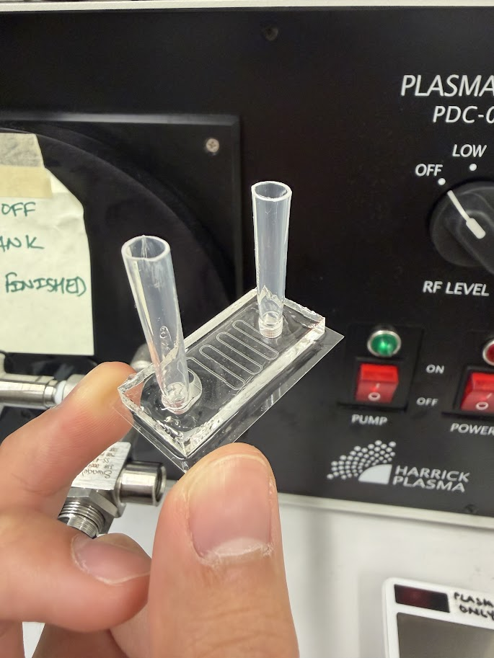
Glass cover slip
PDMS Chip
Inlet/outlet pipette tips
General schematic of a microfluidic chip.
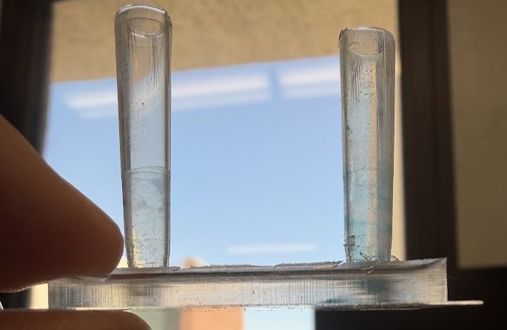

Pipette depth
Here you can see that the pipette does not reach the bottom of the chip, and therefore there is space for flow to happen. If the pipette reaches the bottom there will be a block and the chip will not function properly.
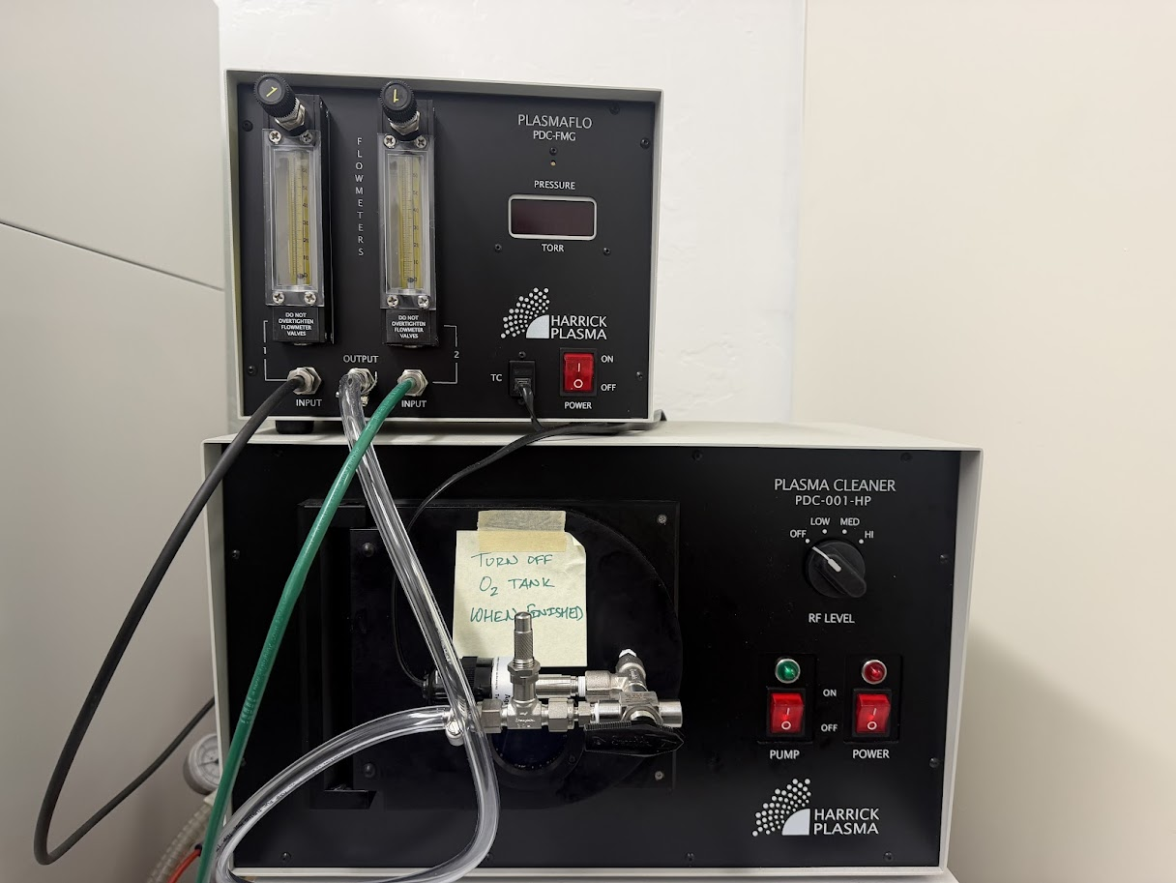

4f.) Flowmeter knobs
4g.) Plasma Level
4a.) Vacuum, Plasma on/off
4b.) Black knob
4e.) Silver knob

4a.) Barometer on/off
Plasma treatment set up with labeled parts corresponding to the steps for Plasma bonding.
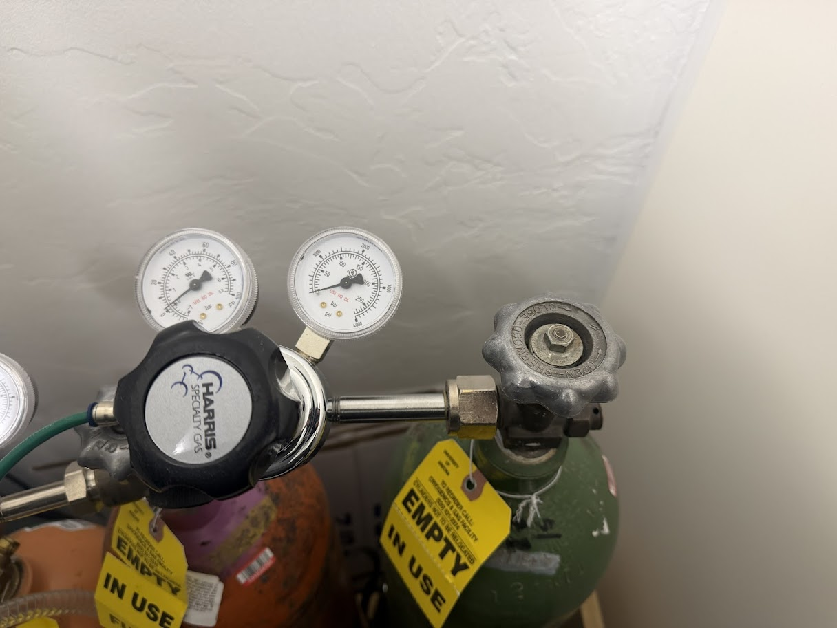

4d.) Main gas tank knob

Delivery Pressure Gauge

Cylinder Pressure Gauge

Regulator Dial
This is the typical gas cylinder set up. The main gas tank knob is the one you twist open for the plasma treatment. The cylinder pressure gauge tells you how much gas is left in the tank.

If this is not shooting up after opening the main gas tank knob, then the tank is likely empty. Make sure to order gas tanks early and before it is completely empty.

The delivery pressure gauge is what is actually being delivered to the plasma chamber. Keep this relatively low with the regulator dial.

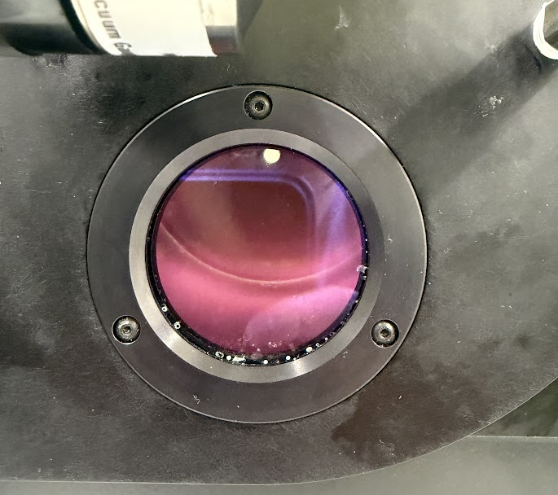
Plasma haze through the window to show it is on.

